**BUSINESS ANALYTICS (A) CLASS ACTIVITY**

**SAYAM SARFRAZ (S2020005047)**

**1ST DASHBOARD:**

1. **SLICER:**

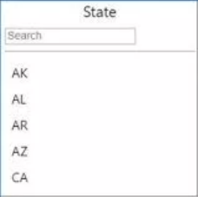

In the first visualization of power BI, it can be seen that there are several states given in it which can be selected by anyone and with the help of that, all the data can be filtered and analyzed according to the one of the selected state.

1. **GAUGE:**

* 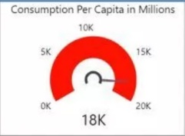**1ST GAUGE:**

In the 1st gauge made for the Samsung the maximum value can be seen and it can also be seen in it that, that how many people per capita in millions are using their products.

* 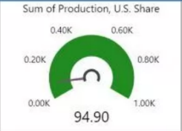**2nd GAUGE:**

In the 2nd gauge, it can be seen that it is showing the minimum value especially according to the gauge it can be seen that it is mostly telling about the US share in it.

* 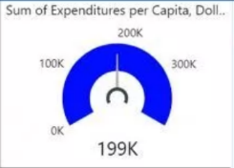**3rd GAUGE:**

In the 3rd gauge it is shown the current value and it can also be seen that it is explaining about the funds that are spent by the company on their overall in per capita.

1. **TREEMAP:**

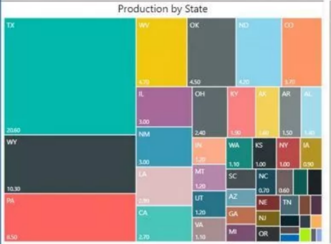

In the treemap, the data is placed in hierarchy in the rectangular boxes and it can also show lot of data on the treemap if necessary and in the Samsung’s data treemap, it can be seen the data placed in the treemap shows Samsung’s production according to each state.

1. **FILLED MAP:**

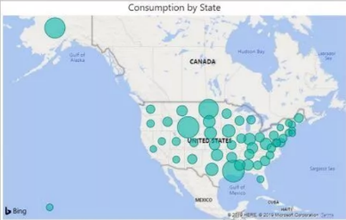In the filled map, the locations on the map is marked with points with which the data is related and also the samsung’s visualization is showing the consumption that people are doing of samsung’s products and where those consumers are from in the USA.

**2ND DASHBOARD**

1. **STACKED COLUMN CHART:**

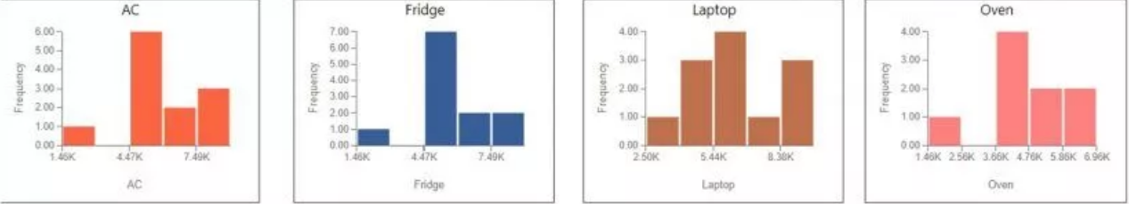

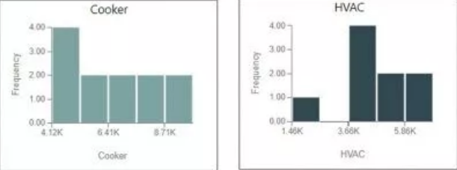

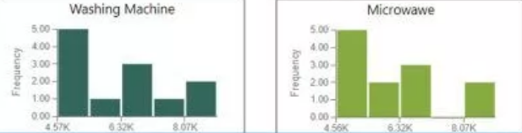

The stacked column chart basically shows the line chart and and column chart together and it shows all of the data given on the one single chart called the stacked column chart, the samsung’s stacked column chart shows the comparison between the frequency of the several products of theirs and it is also being compared with the frequencies of those products with their prices.

1. **STACKED BAR CHART:**

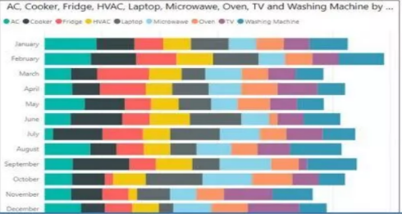

In this chart, the multiple dimensions are compared with a single measure and in the samsung’s bar chart it can be seen the amount of sales of their products according to different months in which they were operating.

**3RD DASHBOARD**

1. 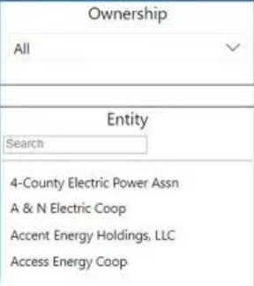**SLICER:**

In this it can be seen that the samsung’s stakes and their holders can be seen and they can be selected individually.

1. **DONUT CHART:**

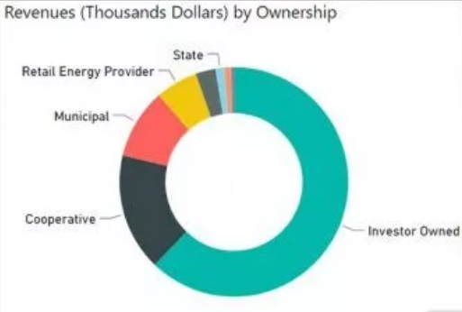

The donut chart explains all data by showing relevant information and comparison with each other in this donut chart it can be seen stats, retail energy and overall revenue by ownership of the company.

1. **STACKED AREA CHART:**

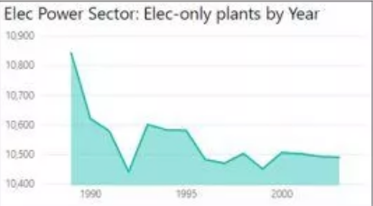

In this chart it can be seen the electric power sector supply and its production by its year, and also the production can be seen with the year being compared.